BUILDING A DOCKER IMAGE FROM A SPRING BOOT PROJECT USING MAVEN
NAME: SRIDHAR S
ROLL – NO:23ISR055

Step 1: Cloning the Spring Project Repository
This step downloads the Spring framework project from GitHub to the local VM.Cloning creates a local copy of the source code for building and containerization.
Commands to Run:
- git clone <repository-url>
- cd <project-folder>
- 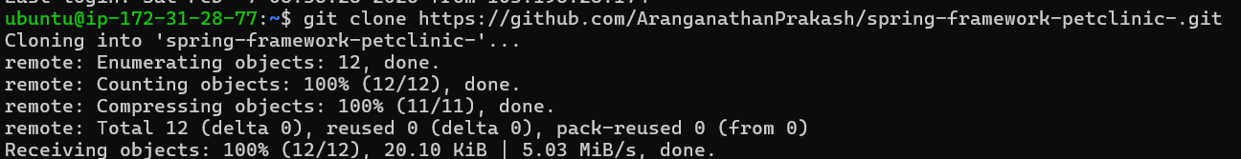

Step 2: Installing Maven
This step installs Apache Maven, which is used to build and manage dependencies for Spring projects.Maven compiles the project and generates the executable JAR file.
Commands to Run :
- sudo apt install maven
- mvn install

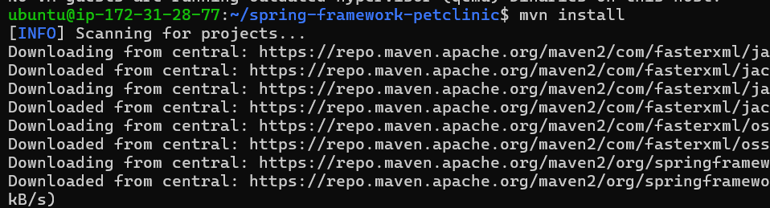

Step 7: Building the Docker Image and Verifying
This step builds the Docker image from the project directory using the Dockerfile and assigns a custom image name.After building, the image can be verified from the local Docker image list before running a container.
Commands to Run:
- docker build -t imagename .
- docker images
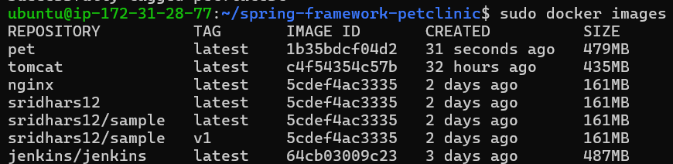

Step 8: Running the Docker Container and Verifying in Browser
This step runs the Docker image as a container in detached mode and maps the application port to the host system.
Command to Run:
- sudo docker run -itd -p 60:8080 springappimagename
- 